Dear Customer,

Thank you for your Order. We would like to draw your attention that after checking design file sent by you we have made certain observations and given actions taken by us for the same.
Click here to reply online http://login.pcbpower.com/V2/login.aspx ➔ Exception Section ➔ Select and reply

Technical Observation 1:

- Here we have attached schematic PDF file for further approval of given design please check and confirm.

Technical Observation 2:

- Also we have attached netlist file please check and confirm.
- Below are the open nodes in the schematic given by you so please check and confirm.
- Net ~CLR6 has only one pin (Pin U8-22)
- Net CLR6 has only one pin (Pin SV10-12)
- Net 3.3V has only one pin (Pin SV9-1)

- Please let us know ~CLR6 and CLR6 are the same net .And also let us know that 3.3V net name is same as +3.3V .please let us confirm.

- Some of net names and designators doesn't match between the schematic pdf provided by you and the eagle file provided by you.Inorder to verify we required updated schematic pdf from your side .

- Please check below image marked in red from the pdf and eagle file provided by you an we found differnce between them in net name AGND and GND .Please check and confirm.

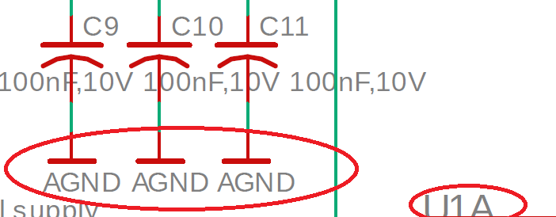
Illustration 1: Image from pdf given by you
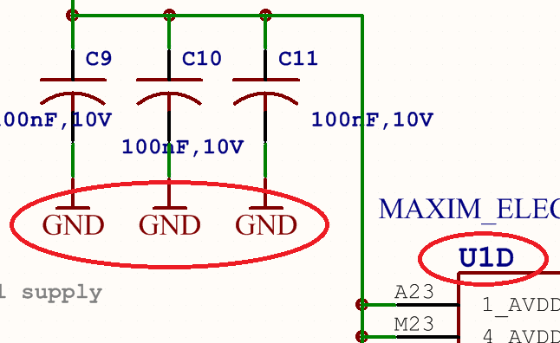
Illustration 2: Image from imported eagle file

- For below image marked in red check the connection in the schematic pdf attached by us and confirm.
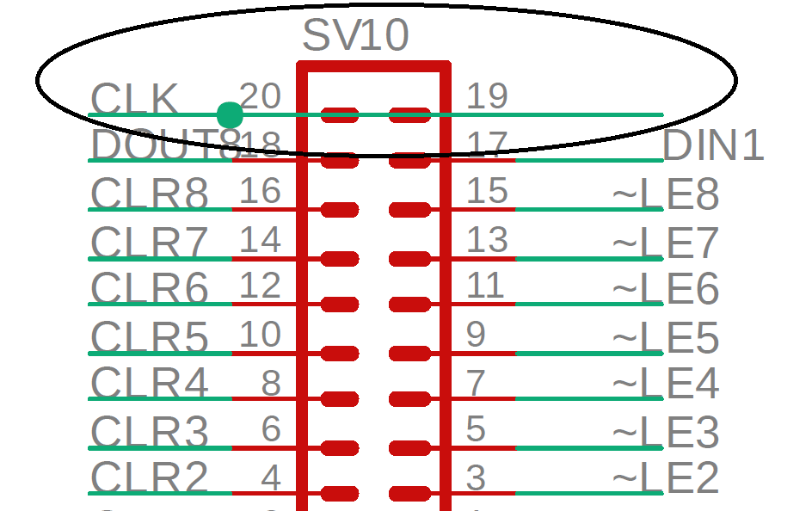

- In the below image marked in red let us know where the SV2 pin 10is connected.

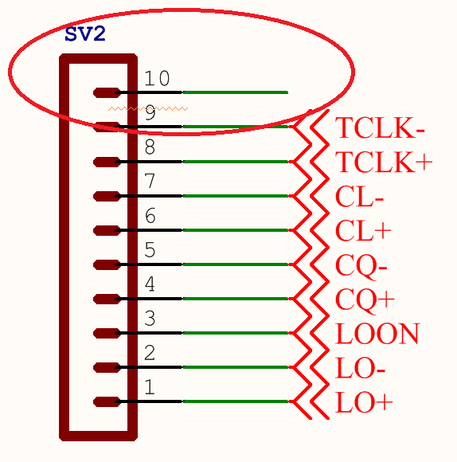

- The BOM related queries are as below:
- Please provide the manufacturer partnumber for below components
- C46,C100 - Please provide the manufacturer part number/datasheet /link to datasheet.
- J1 - Please provide the manufacturer part number/datasheet /link to datasheet.
- PULSE_1,PULSE_5 - Please provide the manufacturer part number/datasheet /link to datasheet.
- SV1 to SV10 - Let us know if you required standard 2.54mm bergstick or else provide the manufacturer part number
- X1,X2,X3,X4 - Please provide the manufacturer part number/datasheet /link to datasheet.
- R48 to R53 not found in BOM give by you so please provide its package or partnumber.

- Please provide the pcb size if exist.
- Please let us know if you require any mounting hole.
- Please provide the image if you require any logo on pcb.
- Please let us know if you have any fixed component placement.

Let us know if you required any changes.

Suggested solution by PCBPOWER:

Please check it and provide feedback for further process.

